**Name**: Shrook Elsayed Mahmoud Emara

**B.N/**380

**Date**: 6-6-2021

**Topic**: Artificial Intelligence

**Application Brief**:

This field is the future and I want to know about it

**GitHub-Link:**

[https://github.com/Shorouk555/sh-project](https://github.com/Shorouk555/-shorouk-project)

**GitHub-Page(Published Website):**

# [https://Shorouk555.github.io/sh-project/figure.html](https://eslam548.github.io/html-project0-repository/figure.html)

**Screenshots**:

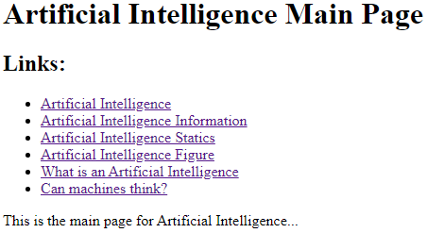

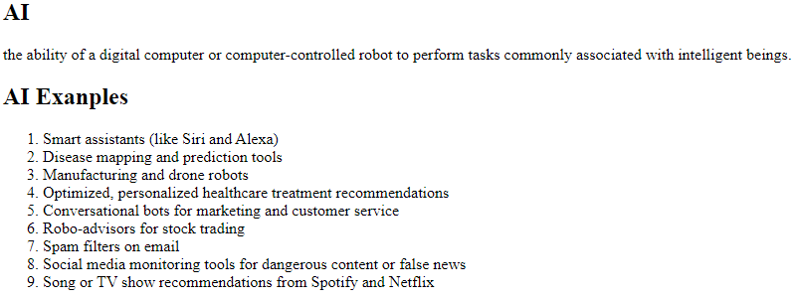

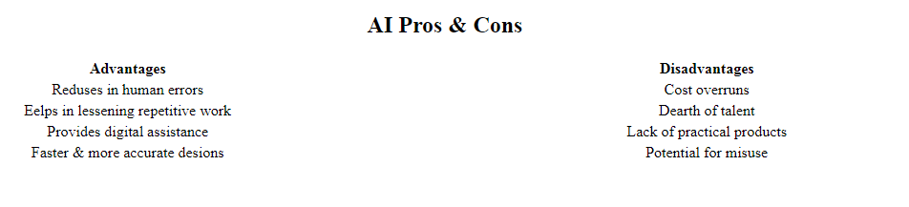

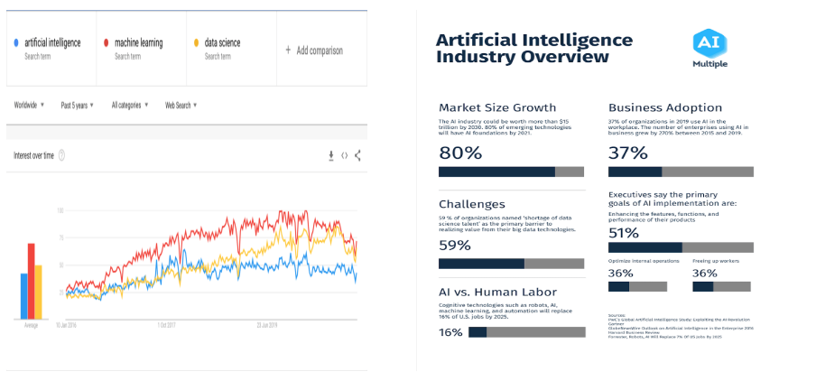

**Source Code**:

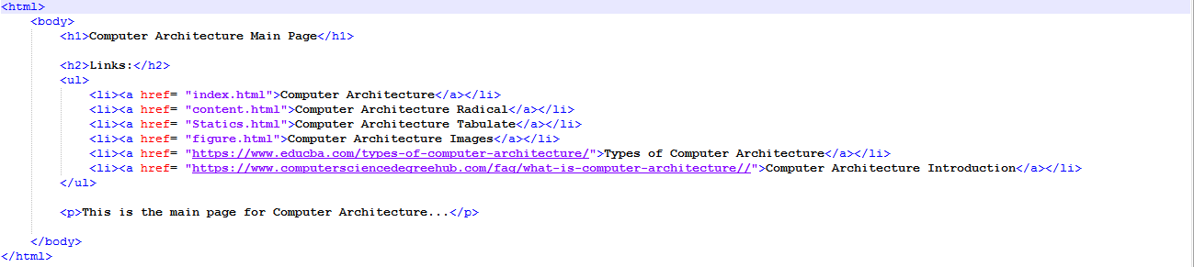

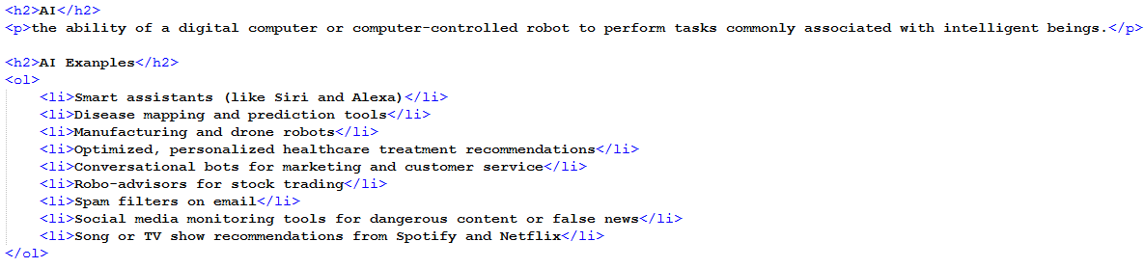

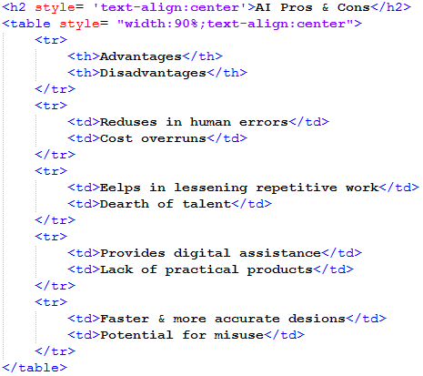

8